Year 13 NEA

To what extent is Mermaid Quay a Fortress Landscape?

Figure - Map of Mermaid Quay https://www.google.co.uk/maps/place/Mermaid+Quay,+Cardiff/@51.4635816,-3.1680653,534m/data=!3m2!1e3!4b1!4m5!3m4!1s0x486e0337c76d4031:0xf94e95c4c6431b7a!8m2!3d51.4635816!4d-3.1658766 (Accessed: 1st November 2022 10:11)

Joshua Netherton

Cleeve Sixth Form Centre of Excellence

Year 13 NEA

Contents

Introduction 2

Hypothesis 2

Specification Link 2

Theory and Research 2

Hypothesis Breakdown 5

1. Crime in Mermaid Quay occurs prevalently 5

2. Evidence of major fortification of Mermaid Quay is present. 6

3. Distribution of fortification is widely spread and even throughout Mermaid Quay. 6

Table of Figures 7

Bibliography 8

# Introduction

## Hypothesis

I have three hypotheses that will answer my main question. They are:

1. Crime in Mermaid Quay occurs prevalently.
2. Evidence of major fortification of Mermaid Quay is present.
3. Distribution of fortification is widely spread and even throughout Mermaid Quay.

## Specification Link

My title links to multiple sections of the course. 3.2.1.1 is Globalisation and in a world ever expanding and growing, in terms of both population and security, fortress landscapes are both changing and growing ever more prevalent. Section 3.2.3.2 is Urban Forms, and different ways of fortifying links to this section. In Section 3.2.2.1 which is the nature and importance of place allows me to look at why somewhere like Mermaid Quay would be fortified.

Finally, the skills I will use to collect data links to Section 3.2.2.3, where I will use both numerical and worded sources of data to answer my sub-questions.

## Theory and Research

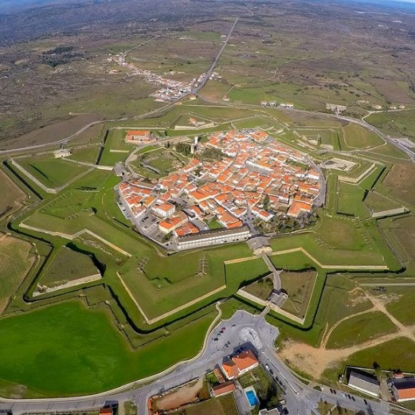Throughout this document links will be made to the subject specification, which is AQA A-Level geography. The work I am doing will come from a certain section of the course I am studying and will typically link to more than once section. My investigation title is “To what extend is Mermaid Quay a fortress landscape?” This ties into primarily section 3.2.1.1 Globalisation and 3.2.3.2 Urban forms. Here we can investigate how Mermaid Quay is developed as a Fortress Landscape while serving its purpose as a shopping centre in the Cardiff Bay area.

Fortress Landscapes are deliberately landscaped and designed around security, protection, surveillance, and exclusion. [1] More prevalent in medieval era constructions you can visually see the defences in place, such as walls and moats, along with typical construction taking place at strategic high points with good visibility. Theses methods are done with the intend to provide the most security and safety to the inhabitants of the facility.

In the modern era it is less prevalent to see such blatant techniques, however, this isn’t to say methods aren’t still used that line up with the continued existence of fortress landscapes. Features such as CCTV (Closed Circuit Television), security alarms, gated communities, and speed bumps are all day-to-day features of towns and cities designed to protect and seclude residents.

Figure - Sky view of fortress https://www.atlasobscura.com/places/fortress-of-almeida (Accessed: 1st November 10:01

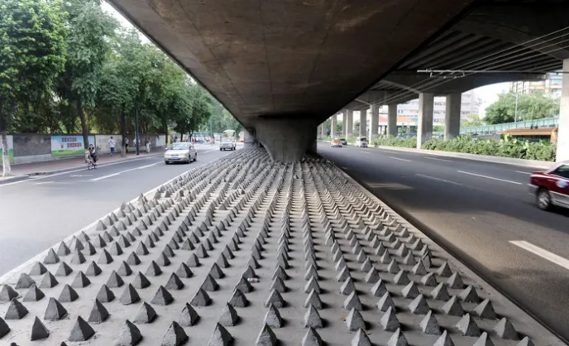 One controversial fortress landscape more prevalent in modern day cities is anti-homelessness architecture. This is defensive architecture, hostile designs, or exclusionary designs [2] with the intention of preventing homeless people from residing in public spaces. There is a stigma of crime and unsafe behaviour surrounding homeless populations in cities and so city designers are including items such spikes, or contoured designs of benches to prevent the stay of homeless people. This will reduce the number of lingering people, but some see it as inhumane and cruel, considering how much they are already struggling, it isn’t fair to do this on top of that. Mosquito Alarms[3] provide a similar purpose by letting of a high-pitched squeal outside shops to disperse crowds and people are more on board with this, however, this is more designed for temporary crowds with somewhere to go. Anti-homeless architecture is designed to kick people out with no where else to go, hence its controversy.

Figure - Anti-homeless architecture https://www.theguardian.com/society/2015/feb/18/defensive-architecture-keeps-poverty-undeen-and-makes-us-more-hostile (Accessed: 3rd November 2022 10:52)

We can see another example of this in Figure 4, where the seating has been designed to prevent sleeping on by taking a curved design to resemble rocks. Whether this is intentional it is unclear, however, this design does result in no homeless people residing in this spot here in Mermaid Quay.

This is one of many features of a Fortress Landscape present in Mermaid Quay, and my research will investigate what else is present in this area to maintain safety and security. Designed as a seaside shopping spot in a once run-down area of Cardiff Bay. It has been significantly redeveloped and a large part of that – similar to many modern cities – has been ensuring safety and security is present and maintained but a larger part for Mermaid Quay has been ensuring that the look and feel of the area has not been tainted by features designed for this purpose. In Figure 3 the spikes could be considered an eye soar, not pleasant to look at and unfriendly for pedestrians passing by. Mermaid Quay’s approach is a much more appealing approach to preventing homeless people from sleeping in this area.

Figure - Anti-homeless architecture in Mermaid Quay Joshua Netherton (20th October 2022)

Figure - Highlight of Mermaid Quay https://www.google.co.uk/maps/place/Mermaid+Quay,+Cardiff/@51.4640905,-3.168601,16.11z/data=!4m5!3m4!1s0x486e0337c76d4031:0xf94e95c4c6431b7a!8m2!3d51.4635816!4d-3.1658766 (Accessed: 4th November 2022 11:04)

Figure - Map of Cardiff https://www.google.co.uk/maps/@51.4819126,-3.1767277,13z (Accessed: 4th November 2022 11:04)

Mermaid Quay is in Cardiff Bay, in the south of Cardiff City. It is based within the bay area, and by extension is protected by the Cardiff Bay Barrage. Accessible by both road and pedestrian only routes it is easy to access and get to for the majority of people and services.

 Cardiff is found on the South coast of Wales along the Bristol Channel. Once a major exporter of minerals such as coal and iron, following its deindustrialisation throughout 1971-2015 [4] this area is no longer used for industry like it used to be. For a time, Cardiff was a highly industrial export port for the Welsh mineral trade. However, as this industry declined so did the quality of the coastal area. For a time, the area behind the Cardiff Bay Barrage was mud and silt that smelt bad and made this an extremely unattractive place to be. Major regeneration took place in 2000 [5] and this worked on remaking an old dry dock and part of this was also the building of the modern-day Mermaid Bay.

Figure - Map of United Kingdom https://www.google.co.uk/maps/@54.4861569,-7.1862054,6z (Accessed: 4th November 2022 11:15)

Cardiff is located on the south coast of Wales, west of Newport and east of Swansea. It has a railway station, Cardiff Central, along with some of its own internal stations which allow for better connectivity throughout the city. The M4 and the A470 both run through Cardiff allowing for excellent connection with the rest of the country. This also means that nearby towns and villages are able to easily commute into the city. With its proximity to other cities and the ease of connectivity between them, this also permits excellent trade routes and connections between these cities promoting job opportunities and the further share of culture.

Figure - Place map for Cardiff https://www.google.co.uk/maps/place/Cardiff/@51.5517743,-3.7323955,9z/data=!4m5!3m4!1s0x486e02d434ec53f5:0x143406db6586670e!8m2!3d51.483707!4d-3.1680962 (Accessed: 4th November 2022 12:46)

## Hypothesis Breakdown

### Crime in Mermaid Quay occurs prevalently

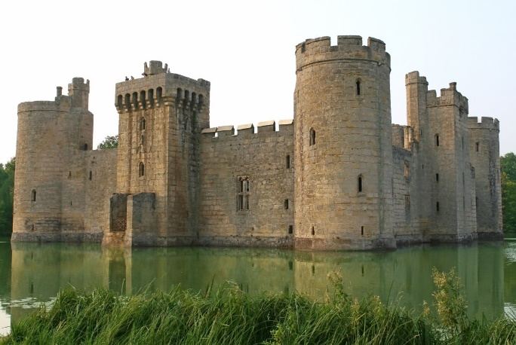Fortification of places occurs with the intent of increasing safety and reducing crime in a place. Simply, a place may have high rates of crime and so it fortifies, or it may fortify to start with to prevent crime from taking place in the first place. An example of the former is a castle. These are built on empty ground with many different defensive features in place to protect it. Crime wasn’t necessarily taking place in that spot prior to construction, but in anticipation of potential attacks, features have been included. In medieval construction, fortress features do differ to modern day techniques, but the concept behind them are the same.

This can be seen in the modern day when new buildings are built with state-of-the-art surveillance and security, new techniques, but a method that dates back hundreds of years. Some places however take a different approach. Whether the methods used are now out of date, or none were used in the first place, sometimes places and buildings need to update their fortress features due to more crime taking place. Somewhere once relatively safe may start seeing increased rate of crime – especially if their methods of defence have become out of date.

Figure - Fortress example https://owlcation.com/humanities/What-Life-Was-Like-in-a-Medieval-Castle-Middle-Ages (Accessed: 8th November 2022 13:14)

Mermaid Quay takes on both approaches. Opening in 1990 and seeing major regeneration since [6] this hypothesis states that crime in this area has increased. My following hypothesis state that fortification has taken place, and with this I am predicting that this is a result of increased or continued crime in the area. It has undergone regeneration and with this more security features have been introduced, and I want this hypothesis to uncover why this has happened.

### Evidence of major fortification of Mermaid Quay is present.

For Mermaid Quay to be considered a fortress landscape major fortification will need to have taken place. Features and development will need to be in this area in many forms, however, to maintain a friendly and welcoming feeling these features cannot be too prevalent or intrusive, or it may ward visitors off. The Big Brother concept is a synonym for abuse of government power, particularly in respect to civil liberties, often specifically related to mass surveillance and a lack of choice in society.[7] In essence it is the idea of constant surveillance by the government, with the idea of keeping people safe, but is taken too far and people begin to lose their sense of privacy.

One thing that developers need to be careful of when fortifying a landscape is taking their methods too far and creating this “Big Brother” feeling in a place. There is a fine line between monitoring somewhere to keep it safe, and intrusive surveillance that undoes the job it is trying to do. As seen in Figure 10, Mermaid Quay possesses CCTV throughout and has both public and private surveillance taking place. Bristol council will monitor Mermaid Quay, but also private businesses will monitor their own property and assets.

Figure - CCTV Features in Mermaid Quay Joshua Netherton (20th October 2022)

Having visited Mermaid Quay I don’t feel that the security measures in place where overbearing or intrusive, but it was clear there was surveillance taking place more so than other areas of Cardiff Bay. This hypothesis is that major fortification has taken place in this area, and using methods outlined in the next section I intend to prove that this is true, and that the methods are adequate for the needs of Mermaid Quay.

### Distribution of fortification is widely spread and even throughout Mermaid Quay.

When developing a place sometimes this development can be uneven and areas which get more funding may see further features implemented. This can happen for many reasons, but typically a divide in finances or funding can result in some areas getting better development than others. Typically, the crime rates reflect this as well. Tending to be higher in the areas with less funding, due to less policing and methods of mitigation.

Sometimes, this can occur with no issue, one place has more fortress development because it needs it, and somewhere else doesn’t have as much because it doesn’t need it. In this case, there is nothing bad about this. Adding CCTV – among other features – to somewhere that doesn’t need it can contribute to that “Big Brother” culture, and so it is best 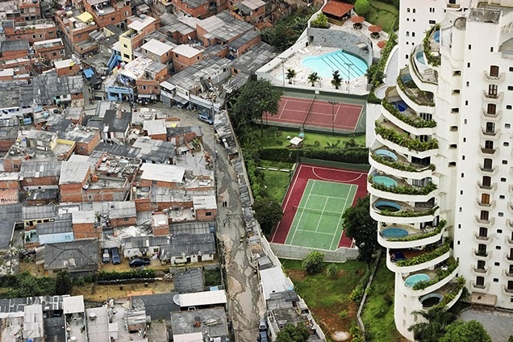to leave it.

As can be seen in Figure 11, São Paulo

Figure - Uneven development in São Paulo https://www.architectural-review.com/essays/exhibitions/uneven-growth-tactical-urbanism-for-expanding-megacities (Accessed: 9th November 2022 11:06)

# Table of Figures

Figure 1 - Map of Mermaid Quay https://www.google.co.uk/maps/place/Mermaid+Quay,+Cardiff/@51.4635816,-3.1680653,534m/data=!3m2!1e3!4b1!4m5!3m4!1s0x486e0337c76d4031:0xf94e95c4c6431b7a!8m2!3d51.4635816!4d-3.1658766 (Accessed: 1st November 2022 10:11) 0

Figure 2 - Sky view of fortress https://www.atlasobscura.com/places/fortress-of-almeida (Accessed: 1st November 10:01 2

Figure 3 - Anti-homeless architecture https://www.theguardian.com/society/2015/feb/18/defensive-architecture-keeps-poverty-undeen-and-makes-us-more-hostile (Accessed: 3rd November 2022 10:52) 3

Figure 4 - Anti-homeless architecture in Mermaid Quay Joshua Netherton (20th October 2022) 3

Figure 5 - Highlight of Mermaid Quay https://www.google.co.uk/maps/place/Mermaid+Quay,+Cardiff/@51.4640905,-3.168601,16.11z/data=!4m5!3m4!1s0x486e0337c76d4031:0xf94e95c4c6431b7a!8m2!3d51.4635816!4d-3.1658766 (Accessed: 4th November 2022 11:04) 4

Figure 6 - Map of Cardiff https://www.google.co.uk/maps/@51.4819126,-3.1767277,13z (Accessed: 4th November 2022 11:04) 4

Figure 7 - Map of United Kingdom https://www.google.co.uk/maps/@54.4861569,-7.1862054,6z (Accessed: 4th November 2022 11:15) 4

Figure 8 - Place map for Cardiff https://www.google.co.uk/maps/place/Cardiff/@51.5517743,-3.7323955,9z/data=!4m5!3m4!1s0x486e02d434ec53f5:0x143406db6586670e!8m2!3d51.483707!4d-3.1680962 (Accessed: 4th November 2022 12:46) 5

Figure 9 - Fortress example https://owlcation.com/humanities/What-Life-Was-Like-in-a-Medieval-Castle-Middle-Ages (Accessed: 8th November 2022 13:14) 5

Figure 10 - CCTV Features in Mermaid Quay Joshua Netherton (20th October 2022) 6

# Bibliography

* *Bishop’s Cleeve photos, maps, books, memories* (no date) *Francisfrith.com*. Available at: https://www.francisfrith.com/bishop-s-cleeve (Accessed: 18 October 2022).

1. https://www.coolgeography.co.uk/advanced/New_urban_landscapes.php#:~:text=Fortress%20landscapes&text=Developments%20are%20deliberately%20landscaped%20and,between%20different%20groups%20of%20people. (Accessed: 3rd November 2022 10:20)
2. https://www.bigissue.com/news/housing/anti-homeless-architecture-hostile-designs/#:~:text=There%20are%20many%20names%20for,in%20a%20town%20or%20city. (Accessed: 3rd November 2022 10:53)
3. https://www.coolgeography.co.uk/advanced/New_urban_landscapes.php#:~:text=Fortress%20landscapes&text=Developments%20are%20deliberately%20landscaped%20and,between%20different%20groups%20of%20people. (Accessed: 3rd November 2022 14:47)
4. https://www.cityevolutions.org.uk/wp-content/uploads/171127-Working-Paper-7-Bristol-Case-Study-Report.pdf (Accessed: 4th November 2022 11:10)
5. https://www.walesonline.co.uk/business/business-news/grand-promises-cardiff-bay-success-14070156#:~:text=That%20name%20is%20a%20legacy,into%20the%20city's%20moribund%20docklands. (Accessed: 4th November 2022 12:34)
6. https://www.mermaidquay.co.uk/history-of-mermaid-quay/ (Accessed: 8th November 2022 13:22)
7. Strouf, J. L. H. (2009) The Literature Teacher’s Book of Lists. 2nd edn. London: Jossey-Bass.